

Chatbot Report





By- Shivam Kumar Giri
CHATBOT AND SIGNIFICANCE
A chatbot is an artificial intelligence (AI) software that can simulate a conversation (or a chat) with a user in natural language through messaging applications, websites, mobile apps or through the telephone. A chatbot is often described as one of the most advanced and promising expressions of interaction between humans and machines. However, from a technological point of view, a chatbot only represents the natural evolution of a Question Answering system leveraging Natural Language Processing (NLP). Formulating responses to questions in natural language is one of the most typical Examples of Natural Language Processing applied in various enterprises’ end-use applications.
There are two different tasks at the core of a chatbot:
1) User request analysis
2) Returning the response
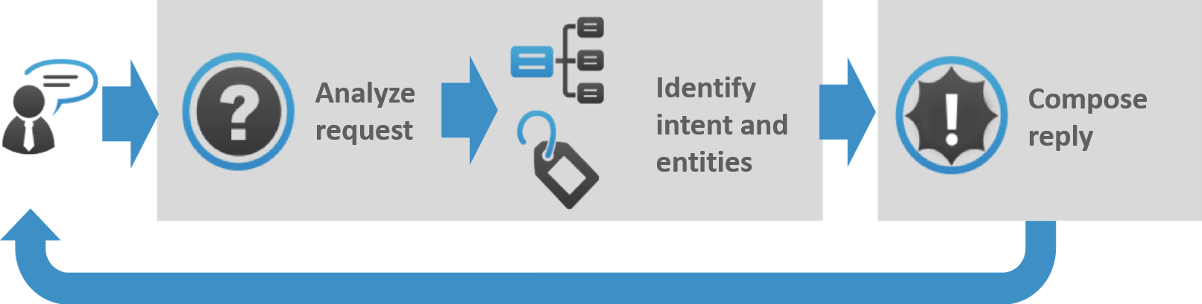
RASA STACK FOR BUILDING CHATBOTS
The Rasa Stack is a set of open-source NLP tools focused primarily on chatbots. In fact, it’s one of the most effective and time efficient tools to build complex chatbots in minutes. Below are three reasons why I love using the Rasa Stack:
- It lets you focus on improving the “Chatbot” part of your project by providing readymade code for other background tasks like deploying, creating servers, etc.
- The default set up of Rasa works really well right out of the box for intent extraction and dialogue management, even with lesser data
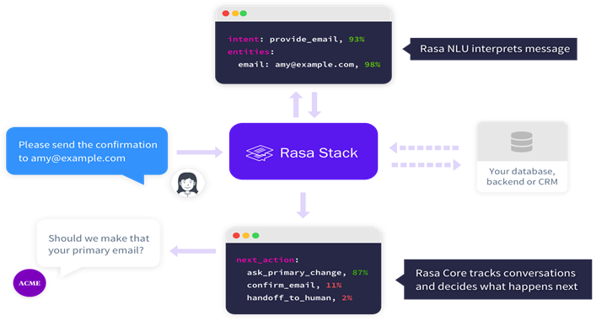
- Rasa stack is open-source, which means we know exactly what is happening under the hood and can customize things as much as we want
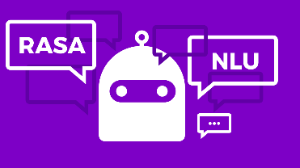

TRAINING DATA
Here’s a training data intent for the chatbot we’ll soon be building:
INTENTS
Sl. No. | ENTITIES | GREETINGS | MENUS | ORDER
 | Meal | Hi | What is there in  The starter? (starter) | I want a regular(quantity) sized cheese pizza(meal)
 | Drink | Hey | Do you have a family table? (seats) | Bring me a chicken lasagna (meal)
 | Quantity | Hello | Do you have a kid dish? (meal and drink) | Get chocolate pastry(dessert) for four(quantity) people?
 | Cost | Whats up | What is best food here? (meal and dessert) | I want to get a birthday cake(dessert) at 12AM (time)
 | Time | Good morning | Would you please tell me the verity of coffee? (drink) | I want Tangy Barbeque sauce(extras) with my chicken Piece(food)
 | Cuisine | Good evening | Do you have sugar free tea? (drink) | I want three chicken wings(food) and a diet coke(drink)
 | Dessert | Good Afternoon | What is the best dish (meal) for today (Time) | I want a sugar free tea (drink) for me
 | Extras | Hallo | What is the best sweet you have? (dessert) | Bring me chicken tikka (meal)
 | Seats | Hello there | You have a Chinese (cuisine) dish | Give me one(quantity) plate samosa chaat (starter)
 | snacks | Howdy | Do You have a spicy dish (meal /starter) | I want two packet chips(snacks), two Frooti and  three coca cola(drinks)
 | Starter | Hey there | Do you have a flavor of ice-cream(dessert) | Can you give me a lunch(time) food under Rs.100? (amount)
 | Amount | Heyyo | Tell me the variety of Biryani (meal) | Pack four tandoor roti and paneer Cholla masala (meal)
 | Discount | I wanna chat | What is cost (cost) of best starter(starter)? | I want 4 Tandoori Rotis (food)
 | delivery | Anyone here | What is the cost of muttons(food) | Get me crispy honey  Chicken (meal)?
 |  | Morning | Can you tell the breakfast(time) item under Rs50(amount) | Bring fresh apple juice(drink)
 |  |  | What dish(meal) are available for lunch? (time)? | Send me 2 (quantity) veg burgers (meal)?
 |  |  | Do you serve Mexican? (cuisine) | Bring chocolate pastry (dessert) for 4 (quantity) people.
 |  |  | What is best starter (starter) under Rs 50 (Amount)? | Bring 1 (quantity) plate fried Rice (meal)?
 |  |  | Are North Indian foods  available? (cuisine) | Get me a north Indian(cuisine) Dal fry (food)?
 |  |  | Is there discount (discount) on Pulav (Meal)? | Bring 5 (quantity) chicken steak(meal)
 |  |  | What is served in soft-drinks? (drinks) | What is discount (discount) on delivery (delivery)?
 |  |  | Do you serve non-spicy dishes(meal)? | Bring fresh Mexican(cuisine) apple juice(drink)
 |  |  | Do you serve Vietnamese (Cuisine) Chicken (Meal/ starter) dish? | I want to order a 2(quantity) veg pizza(meal) with extra  cheese topping (extras).
 |  |  | What is discount (discount) on Mexican (cuisine)? | Get me food(meal) with most (quantity) discount(discount) under 500(Amount)?
 |  |  | What are the cuisines (Cuisine) here? | I want pizza(meal) with chili sauce(extra)
 |  |  | Do you have 4 seats available (seats) | I want plain Dosa (meal) with sambhar(extras)?
 |  |  | What all dinner(time) options(meal) I can get for Rs 500? | I want best sweet (dessert) under Rs400 (amount)
 |  |  | Do you have non-veg dishes (meal)? | Can i get oil free baked chips(snacks).
 |  |  | How much does a Chicken Platter(meal) costs? (cost) | I want a regular(quantity) sized cheese pizza(meal)
 |  |  | Can u suggest me from one of the bestsellers  Dishes (meal /dessert/ drinks/cuisine) | I want most expensive(cost) food(meal).
CONCLUSION
Chatbots have a wide array of applications, even more than the above mentioned few of them. Since data shows that more and more people are more comfortable to chat rather than call there will be a demand for use of chatbots by several industries. It would gravely improve their revenues and customer satisfaction. With technology moving faster than ever before, it has become very easy to create a chatbot with so many platforms out there. During the COVID-19 pandemic, many chatbots were deployed to provide information to end users.
THE END

